Obtuse Triangle
# Source: AI Source: Provided by: [Data Path: Persons Table -> ID Column: 1, Name_En Column: Motasem Essam] -> From: [ChatGPT] on [7/25/2026]
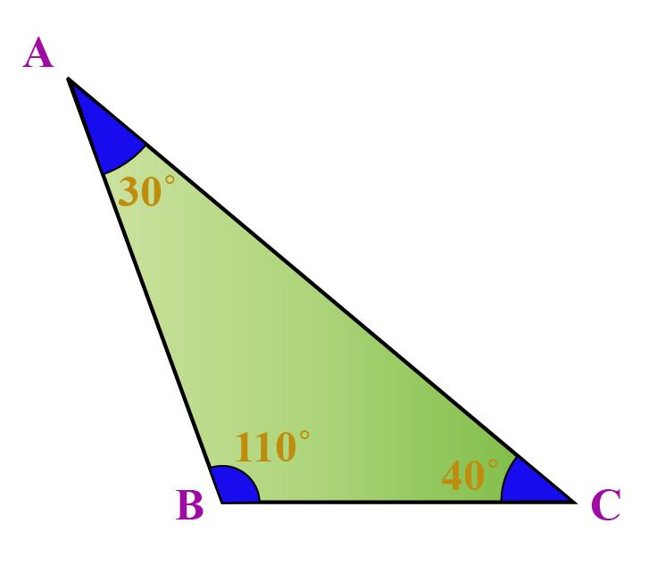
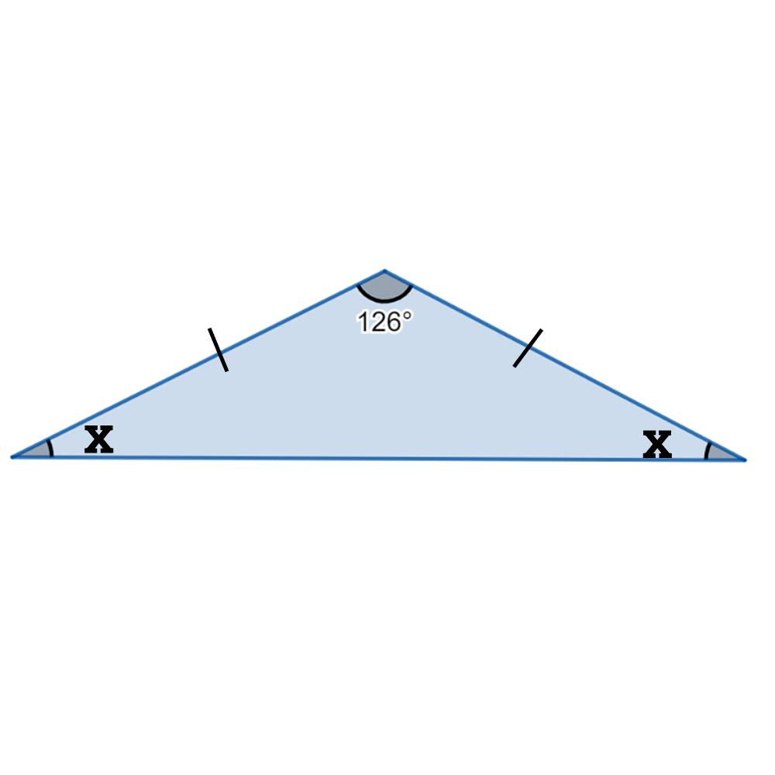
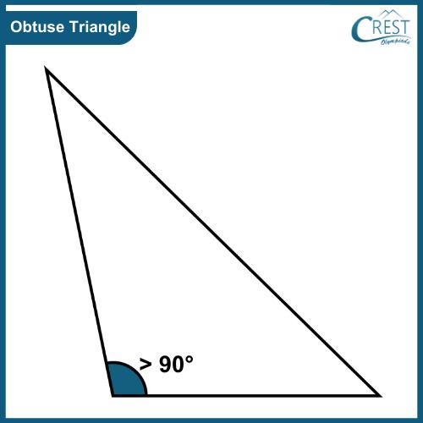
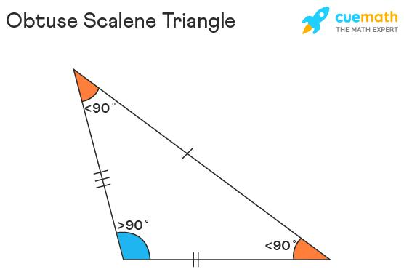
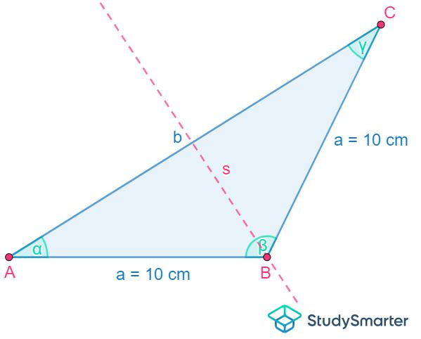

Definition
# Source: AI Source: Provided by: [Data Path: Persons Table -> ID Column: 1, Name_En Column: Motasem Essam] -> From: [ChatGPT] on [7/25/2026]
An Obtuse Triangle is a triangle that has exactly one interior angle greater than ${90}^{∘}$and less than ${180}^{∘}$.
For triangle $ABC$, if:
$$\boxed{∠A>{90}^{∘}}$$
then $△ABC$is an obtuse triangle.
The other two angles must be acute:
$$\boxed{∠B<{90}^{∘}, ∠C<{90}^{∘}}$$
because the three interior angles of a triangle always sum to ${180}^{∘}$.
Therefore:
$$\boxed{{90}^{∘}<∠A<{180}^{∘}}$$

Classification
# Source: AI Source: Provided by: [Data Path: Persons Table -> ID Column: 1, Name_En Column: Motasem Essam] -> From: [ChatGPT] on [7/25/2026]
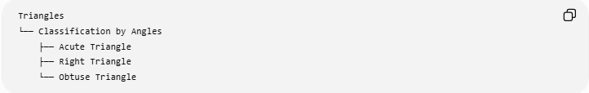
Triangles
└── Classification by Angles
├── Acute Triangle
├── Right Triangle
└── Obtuse Triangle
An obtuse triangle can also be classified according to its sides:
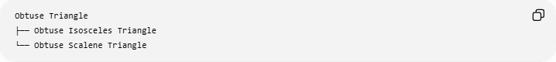
Obtuse Triangle
├── Obtuse Isosceles Triangle
└── Obtuse Scalene Triangle
Important
An obtuse triangle cannot be equilateral, because an equilateral triangle has three ${60}^{∘}$angles.
An obtuse triangle can be:
- Isosceles
- Scalene

Fundamental Properties

1. Exactly one angle is obtuse
# Source: AI Source: Provided by: [Data Path: Persons Table -> ID Column: 1, Name_En Column: Motasem Essam] -> From: [ChatGPT] on [7/25/2026]
An obtuse triangle has exactly one angle satisfying:
$$\boxed{{90}^{∘}<∠A<{180}^{∘}}$$
A triangle cannot have two obtuse angles because their sum alone would exceed ${180}^{∘}$.

2. The other two angles are acute
# Source: AI Source: Provided by: [Data Path: Persons Table -> ID Column: 1, Name_En Column: Motasem Essam] -> From: [ChatGPT] on [7/25/2026]
If $∠A$is obtuse:
$$\boxed{∠B<{90}^{∘}, ∠C<{90}^{∘}}$$

3. Interior angles sum to ${180}^{∘}$
# Source: AI Source: Provided by: [Data Path: Persons Table -> ID Column: 1, Name_En Column: Motasem Essam] -> From: [ChatGPT] on [7/25/2026]
$$\boxed{∠A+∠B+∠C={180}^{∘}}$$
Therefore, if the obtuse angle is known:
$$\boxed{∠B+∠C={180}^{∘}-∠A}$$

Side-Length Characterization
# Source: AI Source: Provided by: [Data Path: Persons Table -> ID Column: 1, Name_En Column: Motasem Essam] -> From: [ChatGPT] on [7/25/2026]
An obtuse triangle can be identified from its side lengths.
Let $c$be the longest side, opposite the obtuse angle, and let $a$and $b$be the other two sides.
The triangle is obtuse exactly when:
$$\boxed{c^{2}>a^{2}+b^{2}}$$
This follows from the Law of Cosines.
Comparison
Triangle type | Condition for longest side $c$
Acute | $$c^{2}<a^{2}+b^{2}$$
Right | $$c^{2}=a^{2}+b^{2}$$
Obtuse | $$c^{2}>a^{2}+b^{2}$$

Relationship Between the Longest Side and Obtuse Angle
# Source: AI Source: Provided by: [Data Path: Persons Table -> ID Column: 1, Name_En Column: Motasem Essam] -> From: [ChatGPT] on [7/25/2026]
The longest side is always opposite the obtuse angle.
If:
$$∠C>{90}^{∘}$$
then the opposite side $AB$is the longest side:
$$\boxed{AB>BC}$$
and:
$$\boxed{AB>AC}$$
More generally:
$$\boxed{\text{Largest angle}↔\text{Longest opposite side}}$$

Examples

Example 1: Obtuse Isosceles Triangle
# Source: AI Source: Provided by: [Data Path: Persons Table -> ID Column: 1, Name_En Column: Motasem Essam] -> From: [ChatGPT] on [7/25/2026]
Consider a triangle with angles:
$$∠A={100}^{∘}, ∠B={40}^{∘}, ∠C={40}^{∘}$$
Since:
$${100}^{∘}>{90}^{∘}$$
the triangle is obtuse.
Because:
$$∠B=∠C$$
the opposite sides are equal, so it is also isosceles.
Therefore, this is an obtuse isosceles triangle.

Example 2: Obtuse Scalene Triangle
# Source: AI Source: Provided by: [Data Path: Persons Table -> ID Column: 1, Name_En Column: Motasem Essam] -> From: [ChatGPT] on [7/25/2026]
Consider:
$$∠A={110}^{∘}, ∠B={30}^{∘}, ∠C={40}^{∘}$$
All three angles are different, and one angle is greater than ${90}^{∘}$.
Therefore, it is an obtuse scalene triangle.

Example 3: Side-Length Test
# Source: AI Source: Provided by: [Data Path: Persons Table -> ID Column: 1, Name_En Column: Motasem Essam] -> From: [ChatGPT] on [7/25/2026]
Consider a triangle with sides:
$$a=4, b=5, c=7$$
The longest side is $7$.
Check:
$$7^{2}>4^{2}+5^{2} \\ 49>16+25 \\ 49>41$$
Therefore:
$$\boxed{c^{2}>a^{2}+b^{2}}$$
so the triangle is obtuse.

Altitudes and Orthocenter
# Source: AI Source: Provided by: [Data Path: Persons Table -> ID Column: 1, Name_En Column: Motasem Essam] -> From: [ChatGPT] on [7/25/2026]
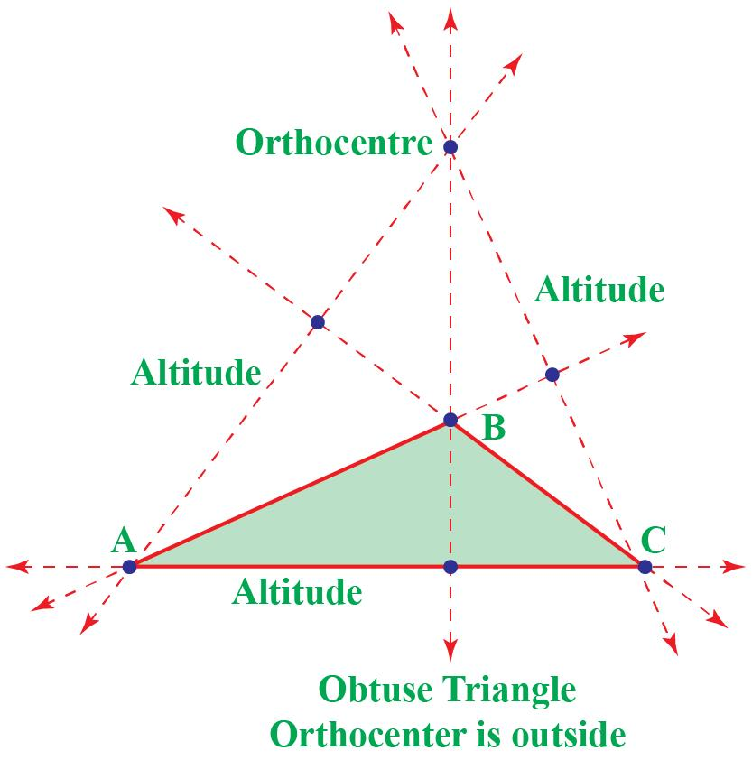
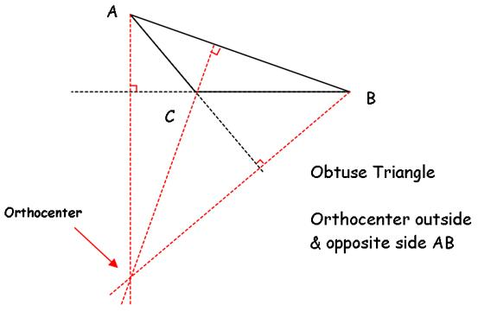
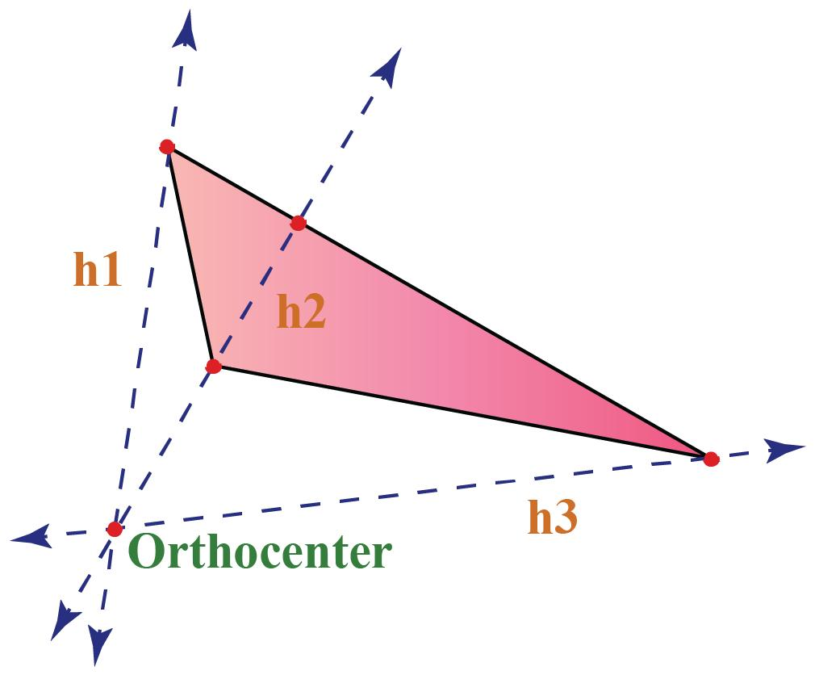
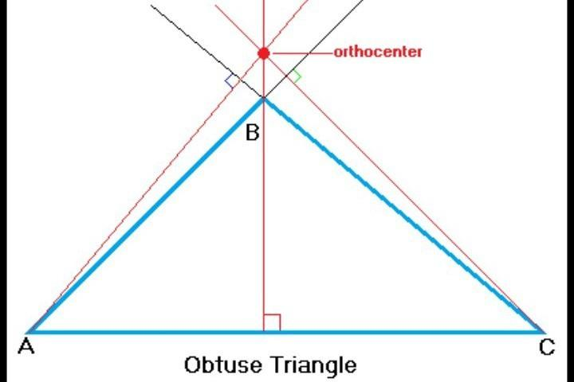
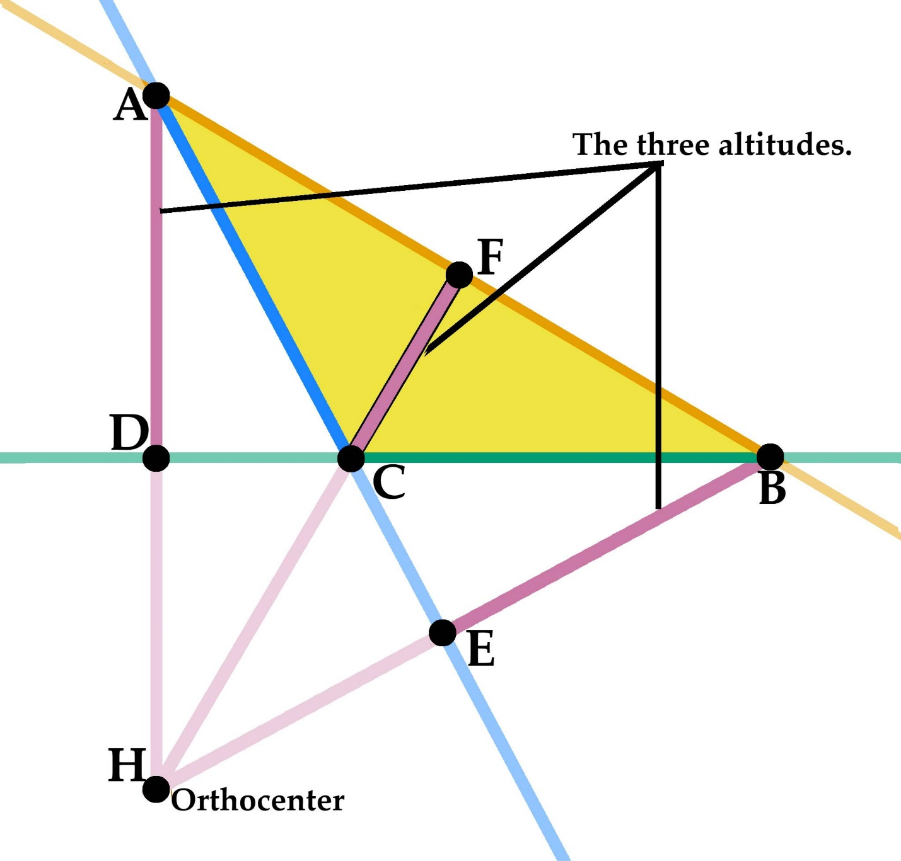
One of the characteristic properties of an obtuse triangle is that its orthocenter lies outside the triangle.
If $H$is the orthocenter:
$$\boxed{H\text{ lies outside }△ABC}$$
The altitudes themselves may need to be extended beyond the sides of the triangle to meet at $H$.
For example:
$$\boxed{AH⊥BC} \\ \boxed{BH⊥AC} \\ \boxed{CH⊥AB}$$

Circumcenter
# Source: AI Source: Provided by: [Data Path: Persons Table -> ID Column: 1, Name_En Column: Motasem Essam] -> From: [ChatGPT] on [7/25/2026]
The circumcenter of an obtuse triangle lies outside the triangle.
If $O$is the circumcenter:
$$\boxed{O\text{ lies outside }△ABC}$$
and:
$$\boxed{OA=OB=OC=R}$$
where $R$is the circumradius.
This contrasts with an acute triangle, whose circumcenter lies inside.

Triangle Centers
# Source: AI Source: Provided by: [Data Path: Persons Table -> ID Column: 1, Name_En Column: Motasem Essam] -> From: [ChatGPT] on [7/25/2026]
For an obtuse triangle:
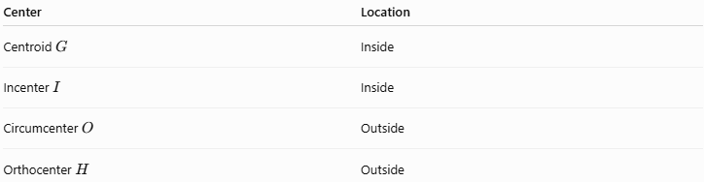
Center | Location
Centroid $G$ | Inside
Incenter $I$ | Inside
Circumcenter $O$ | Outside
Orthocenter $H$ | Outside
The centroid and incenter remain inside because these properties hold for every nondegenerate triangle.
The circumcenter and orthocenter move outside when the triangle becomes obtuse.

Euler Line
# Source: AI Source: Provided by: [Data Path: Persons Table -> ID Column: 1, Name_En Column: Motasem Essam] -> From: [ChatGPT] on [7/25/2026]
For a non-equilateral obtuse triangle, the circumcenter $O$, centroid $G$, and orthocenter $H$remain collinear:
$$\boxed{O, G, H\text{ are collinear}}$$
They satisfy the Euler line relationship:
$$\boxed{OG:GH=1:2}$$
or:
$$\boxed{OH=3OG}$$
Thus, the fact that $O$and $H$lie outside the triangle does not prevent the Euler line from existing.

Area
# Source: AI Source: Provided by: [Data Path: Persons Table -> ID Column: 1, Name_En Column: Motasem Essam] -> From: [ChatGPT] on [7/25/2026]
The area of an obtuse triangle can still be calculated using:
$$\boxed{A=\frac{1}{2}bh}$$
However, when the chosen base is one of the sides adjacent to the obtuse angle, the corresponding altitude may meet the extension of the base rather than the base segment itself.
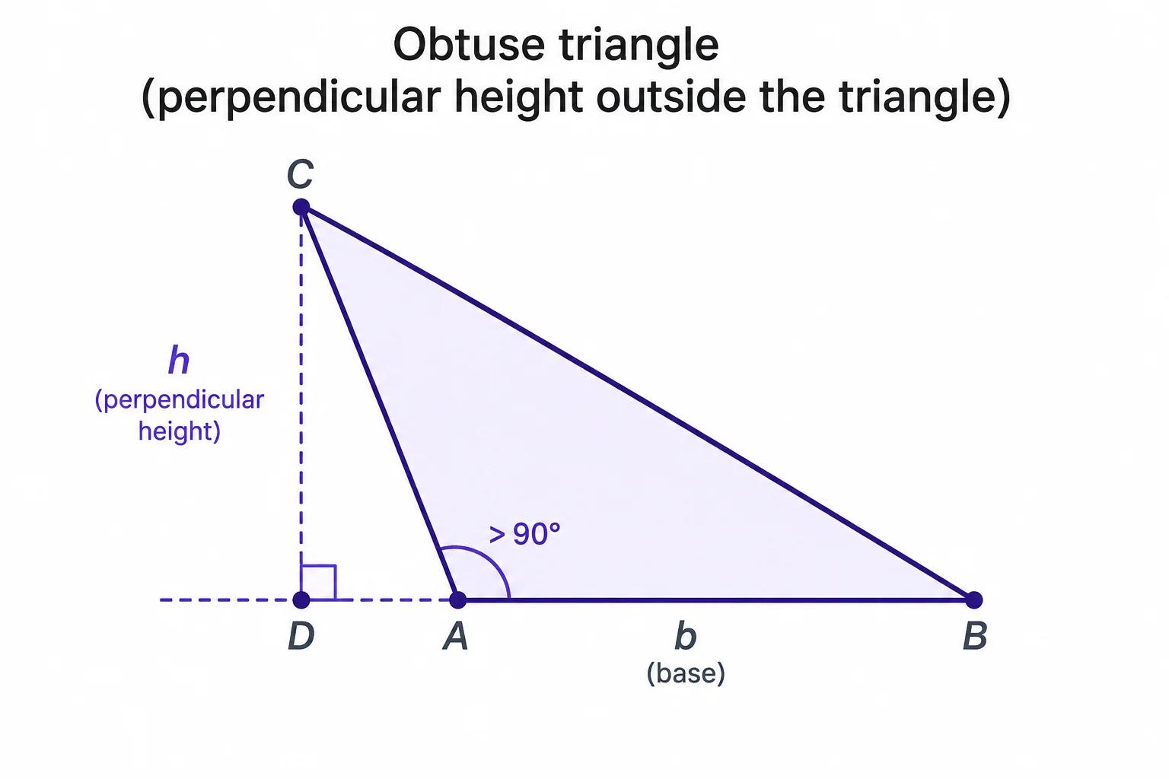
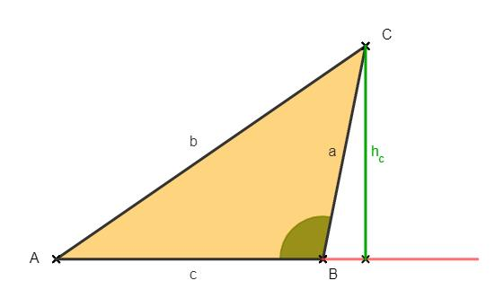
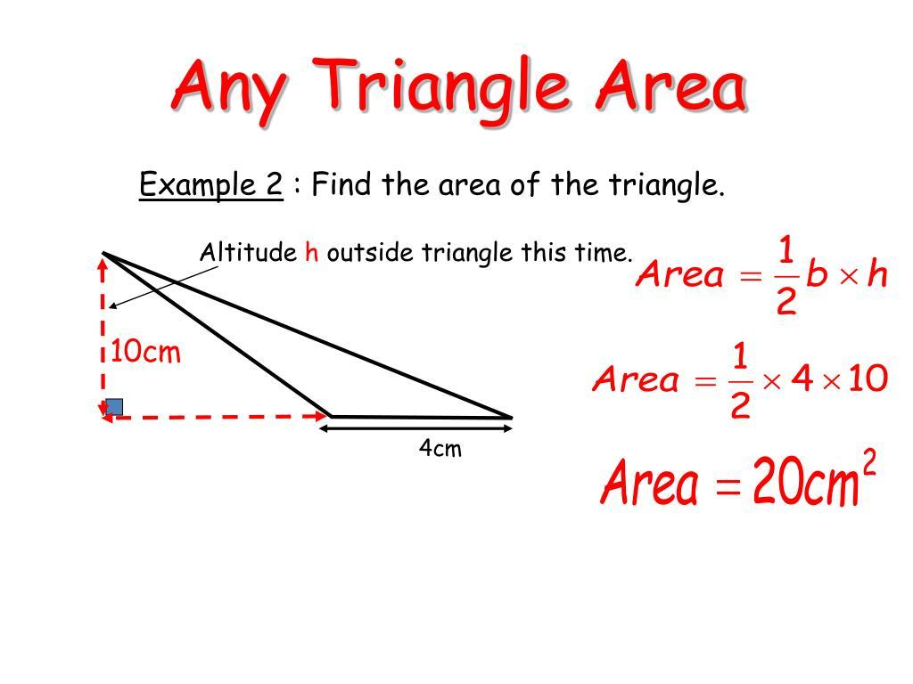
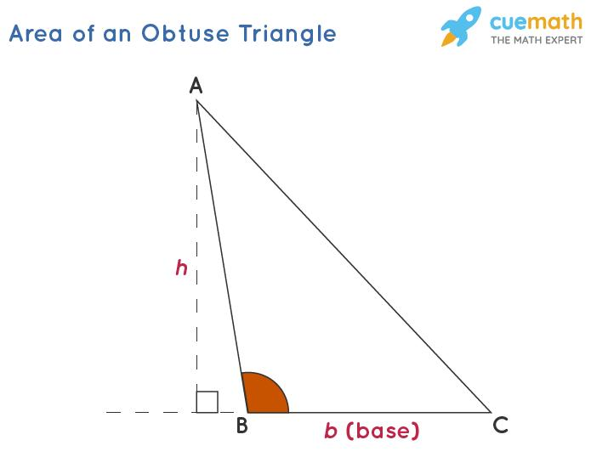
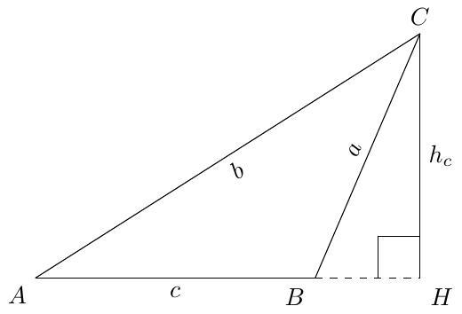
The two-sides-and-included-angle formula also works:
$$\boxed{A=\frac{1}{2}ab\sin{C}}$$
And Heron's Formula works as well:
$$\boxed{A=\sqrt{s\left(s-a\right)\left(s-b\right)\left(s-c\right)}}$$
where:
$$\boxed{s=\frac{a+b+c}{2}}$$

Perimeter
# Source: AI Source: Provided by: [Data Path: Persons Table -> ID Column: 1, Name_En Column: Motasem Essam] -> From: [ChatGPT] on [7/25/2026]
The perimeter is calculated in the same way as for any triangle:
$$\boxed{P=a+b+c}$$
There is no special perimeter formula required for an obtuse triangle.

Can an Obtuse Triangle Be Isosceles?
# Source: AI Source: Provided by: [Data Path: Persons Table -> ID Column: 1, Name_En Column: Motasem Essam] -> From: [ChatGPT] on [7/25/2026]
Yes.
An obtuse isosceles triangle has:
- One obtuse vertex angle
- Two equal acute base angles
- Two equal sides opposite the equal angles
For example:
$${100}^{∘}+{40}^{∘}+{40}^{∘}={180}^{∘}$$
Therefore:
$$\boxed{{100}^{∘}, {40}^{∘}, {40}^{∘}}$$
is an obtuse isosceles triangle.

Can an Obtuse Triangle Be Scalene?
# Source: AI Source: Provided by: [Data Path: Persons Table -> ID Column: 1, Name_En Column: Motasem Essam] -> From: [ChatGPT] on [7/25/2026]
Yes.
For example:
$${110}^{∘}+{40}^{∘}+{30}^{∘}={180}^{∘}$$
Since all three angles are different, the corresponding sides are also different.
Therefore:
$$\boxed{\text{Obtuse Scalene Triangle}}$$

Can an Obtuse Triangle Be Equilateral?
# Source: AI Source: Provided by: [Data Path: Persons Table -> ID Column: 1, Name_En Column: Motasem Essam] -> From: [ChatGPT] on [7/25/2026]
No.
An equilateral triangle always has:
$$\boxed{{60}^{∘}, {60}^{∘}, {60}^{∘}}$$
Since ${60}^{∘}<{90}^{∘}$, every equilateral triangle is acute.
Therefore:
$$\boxed{\text{No obtuse triangle can be equilateral}}$$

Real-World Applications
# Source: AI Source: Provided by: [Data Path: Persons Table -> ID Column: 1, Name_En Column: Motasem Essam] -> From: [ChatGPT] on [7/25/2026]
Obtuse triangles can appear in:
- Architectural structures
- Roof designs
- Bridge and truss systems
- Surveying
- Land measurement
- Engineering layouts
- Computer graphics
- Geographic triangulation
- Structural analysis
The geometric relationships of obtuse triangles are particularly important when calculating distances, angles, heights, and positions.

Comparison with Other Triangle Types by Angles
# Source: AI Source: Provided by: [Data Path: Persons Table -> ID Column: 1, Name_En Column: Motasem Essam] -> From: [ChatGPT] on [7/25/2026]
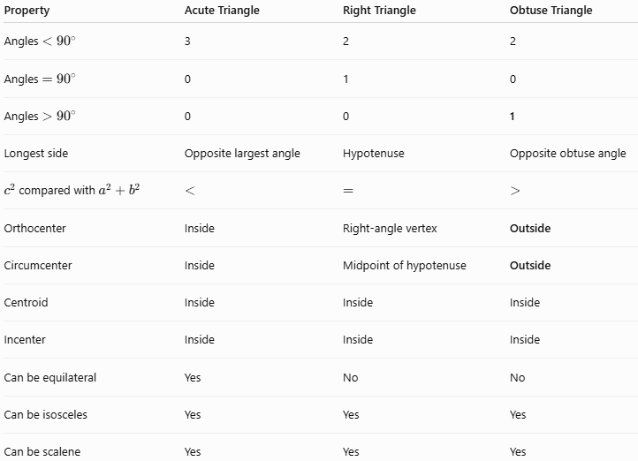
Property | Acute Triangle | Right Triangle | Obtuse Triangle
Angles $<{90}^{∘}$ | 3 | 2 | 2
Angles $={90}^{∘}$ | 0 | 1 | 0
Angles $>{90}^{∘}$ | 0 | 0 | 1
Longest side | Opposite largest angle | Hypotenuse | Opposite obtuse angle
$c^{2}$compared with $a^{2}+b^{2}$ | $$<$$ | $$=$$ | $$>$$
Orthocenter | Inside | Right-angle vertex | Outside
Circumcenter | Inside | Midpoint of hypotenuse | Outside
Centroid | Inside | Inside | Inside
Incenter | Inside | Inside | Inside
Can be equilateral | Yes | No | No
Can be isosceles | Yes | Yes | Yes
Can be scalene | Yes | Yes | Yes

Key Points
# Source: AI Source: Provided by: [Data Path: Persons Table -> ID Column: 1, Name_En Column: Motasem Essam] -> From: [ChatGPT] on [7/25/2026]
- An obtuse triangle has exactly one angle greater than ${90}^{∘}$.
- The other two angles are acute.
- The three interior angles always sum to ${180}^{∘}$.
- The longest side is opposite the obtuse angle.
- If $c$is the longest side:
$$\boxed{c^{2}>a^{2}+b^{2}}$$
- The orthocenter lies outside the triangle.
- The circumcenter lies outside the triangle.
- The centroid and incenter remain inside the triangle.
- An obtuse triangle can be isosceles or scalene.
- An obtuse triangle cannot be equilateral.
- Its area can be calculated using the standard triangle-area formulas.
- In a non-equilateral obtuse triangle, $O,G,H$still lie on the Euler line.

Conclusion
# Source: AI Source: Provided by: [Data Path: Persons Table -> ID Column: 1, Name_En Column: Motasem Essam] -> From: [ChatGPT] on [7/25/2026]
An Obtuse Triangle is a triangle with exactly one interior angle greater than ${90}^{∘}$. Its longest side is opposite this obtuse angle, and its side lengths satisfy $c^{2}>a^{2}+b^{2}$, where $c$is the longest side. Unlike an acute triangle, both the orthocenter and circumcenter lie outside the triangle, while the centroid and incenter remain inside.

